Problem Based Learning 14

Topic : File Handling

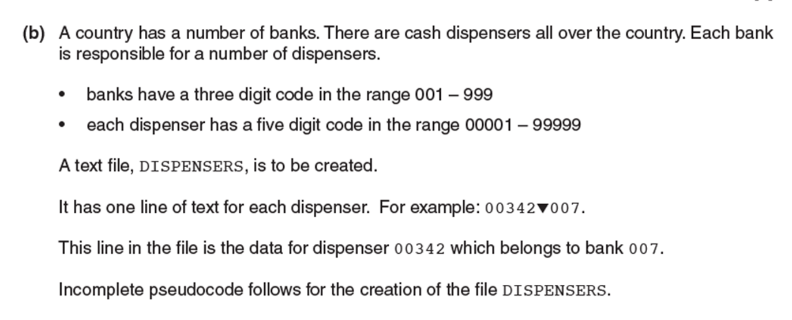

1.

(i) Write a program to create the file and store 10 records in the given format as per the question.

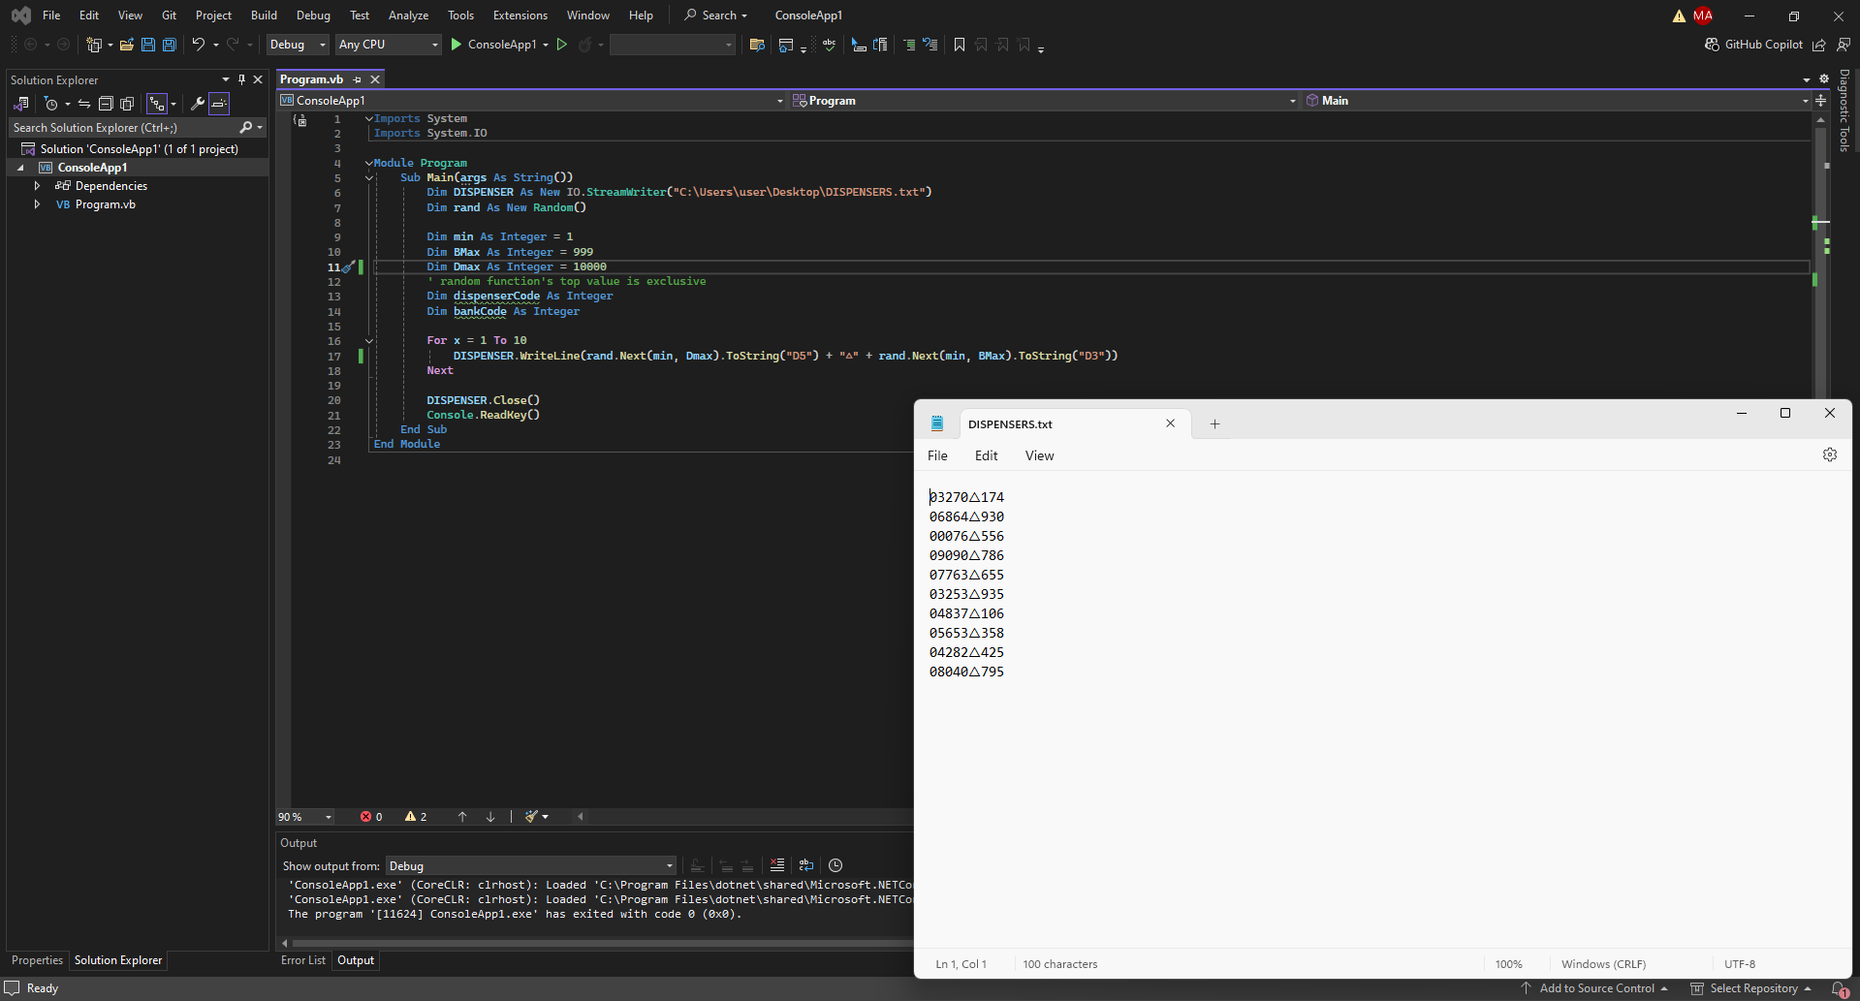

(ii) Write the program to do the following:

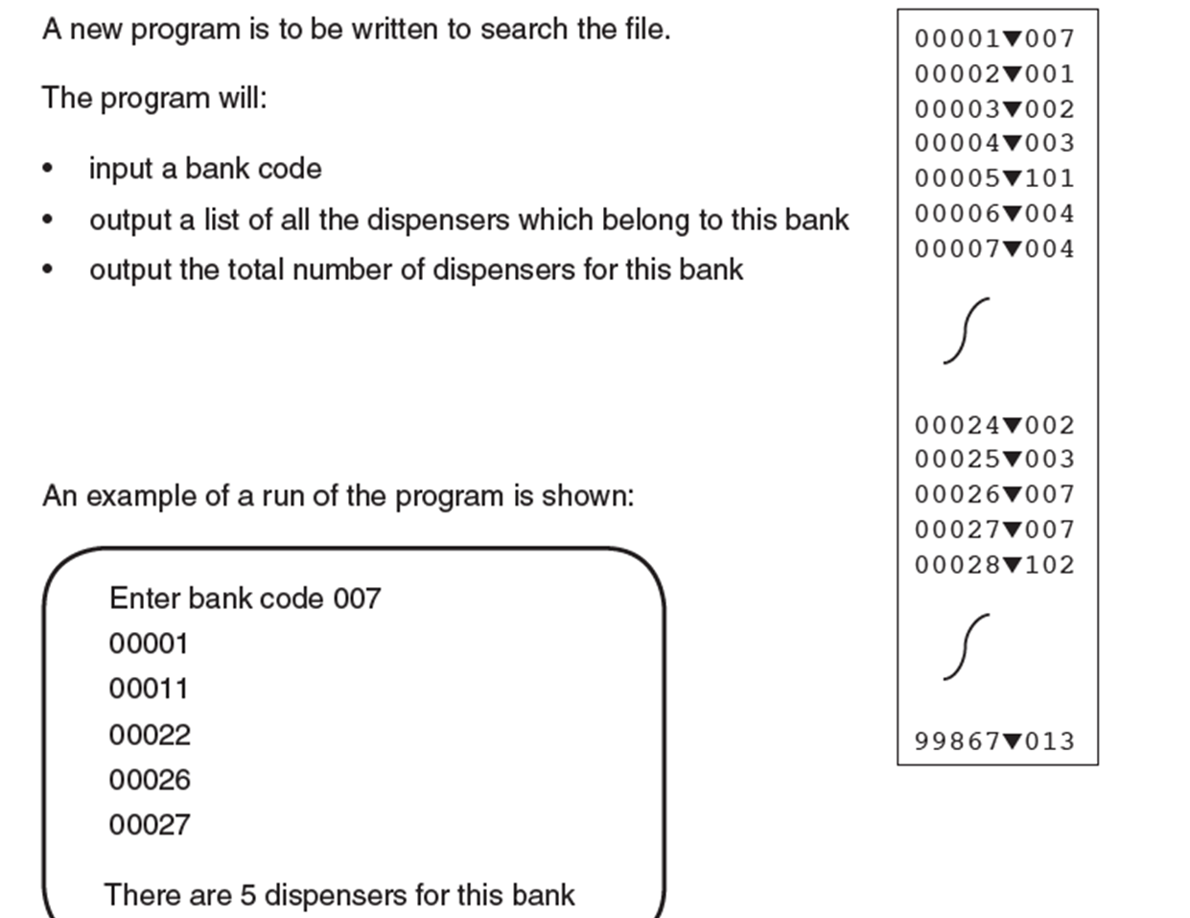

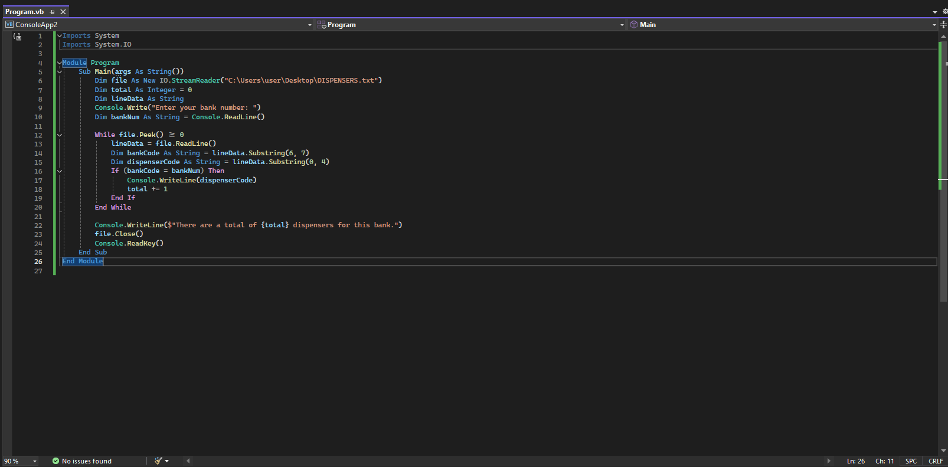

2. A car hire company hires cars to customers. Each time a car is hired, this is treated as a transaction.

For each transaction, the following data are stored.

For the customer:

• customer name

• ID number

The customer data are stored in a text file CUST-INFO.

For the hire:

• car registration

• hire start date

• number of days hired

The transaction data are stored in a text file HIRE-TRANS.

Write a program that will store the data for 5 new customers and 5 hire transactions.

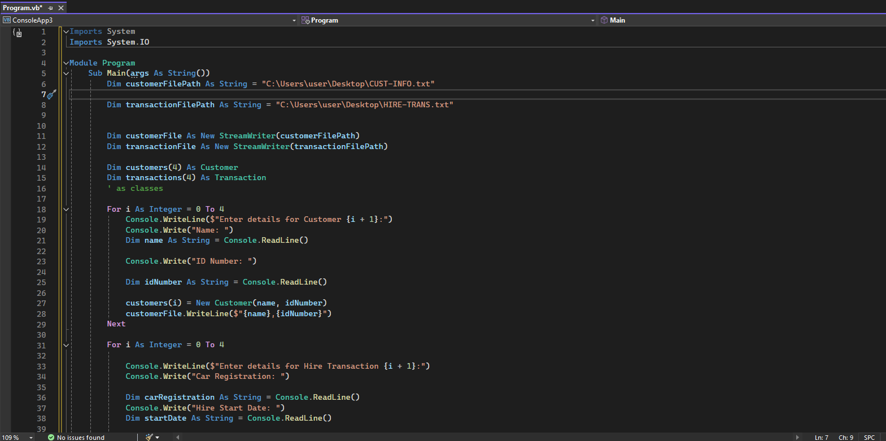

3. A theatre company stores customer login details to allow customers to book tickets online.

Each customer’s details are stored in a record.

The declaration for CustomerRecord is:

TYPE CustomerRecord

DECLARE UserID : STRING

DECLARE PINNumber : INTEGER

ENDTYPE

A 1D array, CustomerDetails, is used to to store the data.

Write a program to store details of 5 customers.